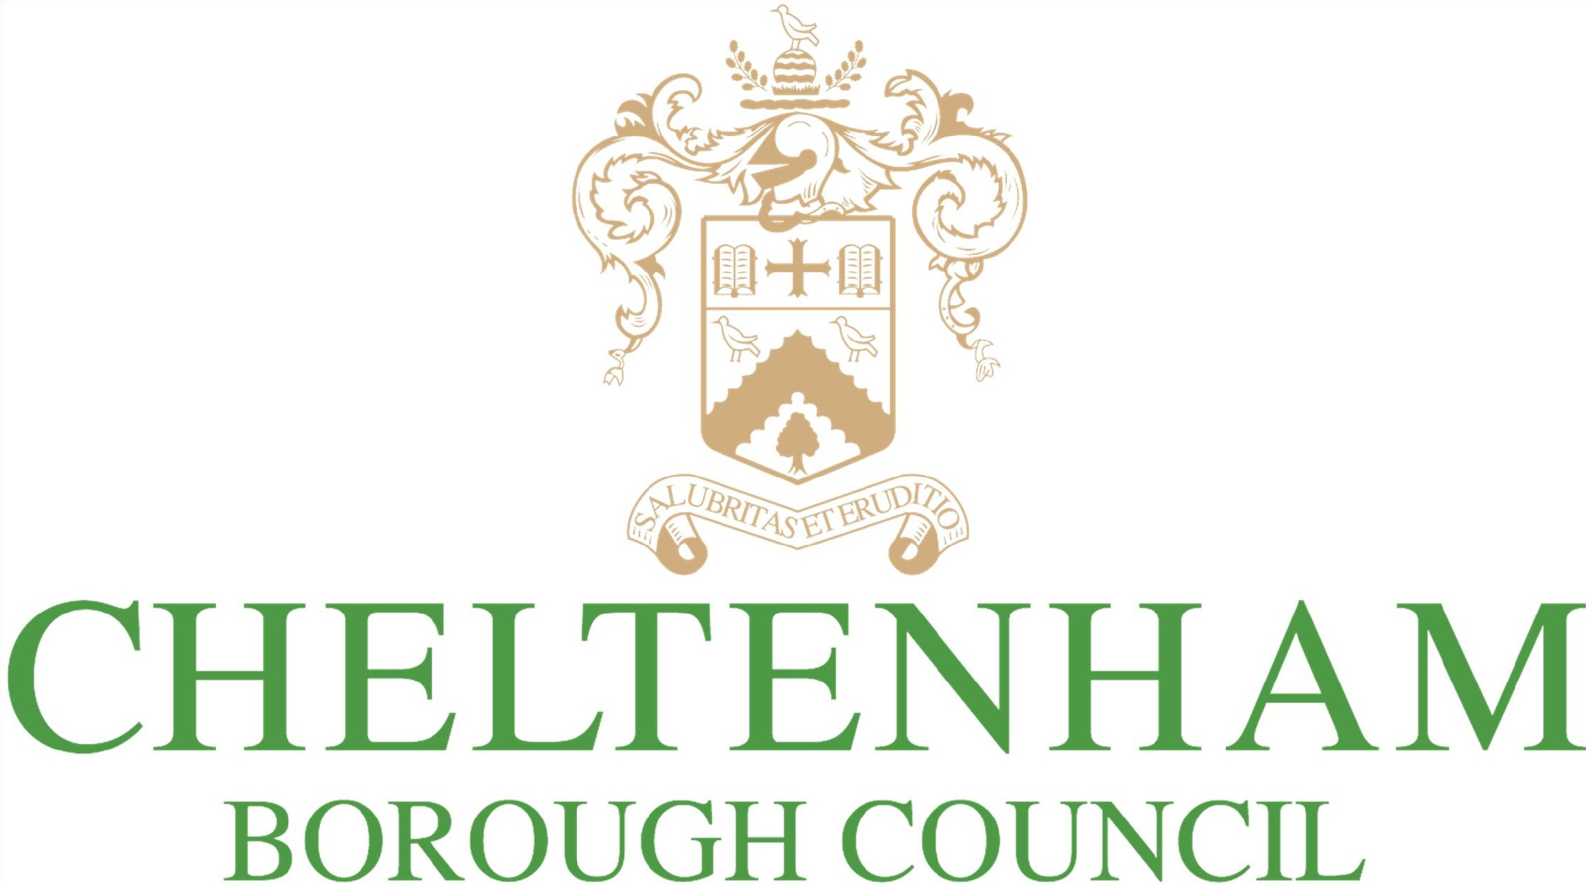
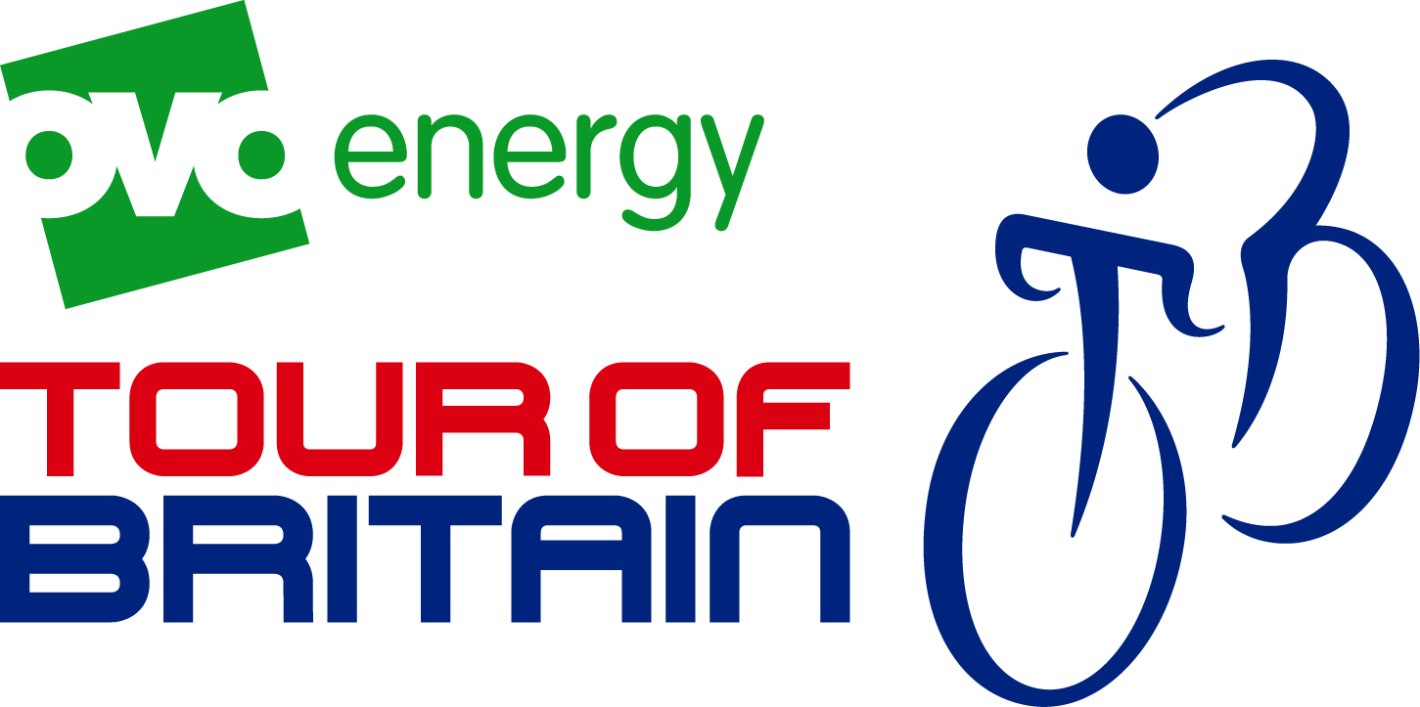
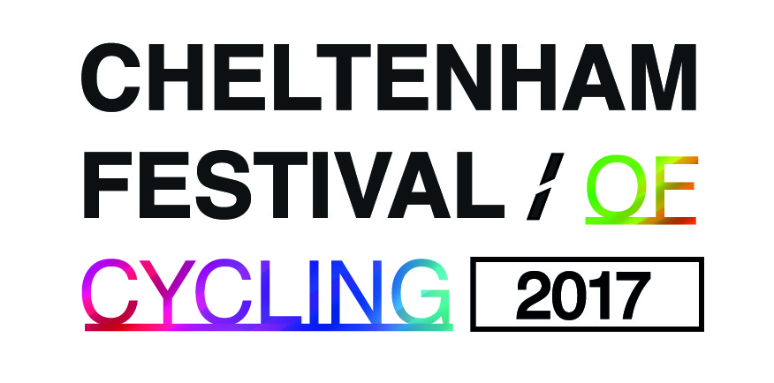

Tour of Britain, Saturday 9th September 2017
Food Providers - Expression of Interest Form

Background

Cheltenham is hosting the penultimate stage of the OVO Energy Tour of Britain this September and Cheltenham Town Centre will come alive with a Festival of Cycling. Residents and visitors will be mere feet from some of the world’s most famous sportsmen as they power past the Racecourse, through the town centre and across the Stage 7 finish line at Imperial Gardens, completing a 115 mile ride from Hemel Hempsted. The wider festival will also include a family focussed event at Pittville Park. Organisers are expecting up to 50,000 visitors to the event, to take advantage of everything the town has to offer.

Cheltenham Borough Council is looking for food providers for this year’s event on Saturday 9th September in the Promenade, Cheltenham and in Pittville Park.

In Pittville Park, the existing café, kiosk and boat house will also be open and the café is providing a BBQ for the event.

Event details

Trading times: 11am – 5pm (Pittville Park) and 11am – 8pm (Promenade) Saturday 9th September 2017
Vacate site by: 7pm (Pittville Park) and 9.30pm (Promenade)
Power: Units will need to provide their own power.
Insurance: £5 Million Public Liability Insurance required
Water: Access to water (for collection) can be provide – please advise if needed.
Documentation required: Public liability insurance; food and hygiene certificates; risk assessment
Litter: Hirers are required to clean and tidy the pitch during and after the event.
Tethering: Please note that the Promenade pitches are on hardstanding, so you will need to bring suitable weights for any tents.
Recycling The council has a responsibility to recycle. Please could you explain how you intend to recycle and remove all your waste after the event?

Pitch fee for the day:
Promenade (11am – 8pm): £480 (£240 for ice cream or coffee units)
Pittville Park (11am – 5pm): £300 (£150 for ice cream or coffee units)

Other information:
- Please see attached terms and conditions of pitch hire

Application

Contact name:

Company:

Address:

Telephone:

Email:

Preferred site: Pittville Park Promenade Either

Site Requirements:

Please indicate the size of the pitch you require and/or size of vehicle (maximum size 6mx 3m)

Proposal
Please give details of what you would provide including what you would sell, your pricing guide and your recycling intentions.

Signed: Name: Date:

Position in organisation:

Please return this form to Helen Down, Cheltenham Borough Council, Municipal Offices, Promenade, Cheltenham, GL50 9SA or helen.down@cheltenham.gov.uk by Tuesday 27 June 2017.

The project team will review all expressions of interest and notify all applicants of the decision made shortly after the closing date.

Payment for the pitch must be made in full by Friday 11 August.

