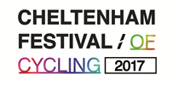 CHELTENHAM FESTIVAL OF CYCLING: PITCHES AND MARKET STALLS

Background
Cheltenham is hosting the penultimate stage of the OVO Energy Tour of Britain this September and Cheltenham Town Centre will come alive with a Festival of Cycling. Residents and visitors will be mere feet from some of the world’s most famous sportsmen as they power past the Racecourse, through the town centre and across the Stage 7 finish line at Imperial Gardens, completing a 115 mile ride from Hemel Hempsted. The wider festival will also include a Kid’s Zone at Pittville Park. Organisers are expecting tens of thousands of visitors to the event, to take advantage of everything the town has to offer.

Cheltenham Borough Council is looking for pitches and stalls for this year’s event on Saturday 9th September in the Promenade and Imperial Gardens, Cheltenham.

By having a stall, any private, public or voluntary sector organisation can take part in the Cheltenham Cycling Festival, with the opportunity to:
- Raise the profile of your organisation
- Sell
- Raise money
- Provide information about services
- Provide fun activities for those attending the Cheltenham Cycling Festival
- Recruit people into your organisation

Stalls will be allocated on a first come first served basis.

Pitches
Premium
A pitch in Imperial Gardens, closest to the Finish Line and Fanzone. You can provide your own stall, or we can provide 1 or 2 of the below market stalls (10ft each).
Price for the day: £1000

Standard
A pitch near Neptune’s Fountain on the Inner Promenade, on hard standing, close to the Finish Line and well placed for media coverage. You can provide your own stall, or we can provide 1 or 2 of the below market stalls (10ft each).
Price for the day: £500

Market Stall
Hire a covered market stall in front of the Municipal Offices on the Inner Promenade. Below is a picture of the market stalls we use. They are individually 10ft in length and 3ft in depth and come in blocks of 3. A 5ft stall would be half of one stall.
Prices for the day:
10 ft stall (full): £50 for voluntary sector and £100 for others
5ft stall (half): £25 for voluntary sector and £60 for others
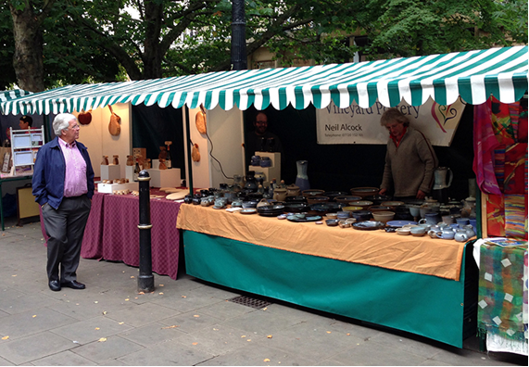

Trading times: 11am – 5pm
Set up: From 8am Saturday 9th September 2017
Vacate site by: 6pm
Power: Stalls will need to provide their own power (if required).
Documentation required: Public liability insurance and a risk assessment may be required if providing an activity.
Tethering: Please note that the Promenade pitches are on hardstanding, so you will need to bring suitable weights for any tents.

CHELTENHAM CYCLING FESTIVAL 2017
Stalls and pitches booking form

Organisation / business name
Contact Name
Email address
Telephone
Are you? Private business ( ) Public Sector ( ) Voluntary Sector ( )

Please describe what your stall or pitch will contain, for example what you are selling, what information you are providing etc

I am interested in

A premium pitch, Imperial Gardens (£1000)
We will provide our stall ( ) OR we would like to use ( ) 10ft market stalls (up to 2)

A standard pitch, Inner Promenade (£500)
We will provide our stall ( ) OR we would like to use ( ) 10ft market stalls (up to 2)

A market stall
5ft (half) ( ) @ £25 for Voluntary Sector or £50 for others
10ft (full) ( ) @ £50 for Voluntary Sector or £100 for others

Please describe any special requirements, for example wheelchair access; space for hanging rail etc.

Please return the booking form as soon as possible to:
Helen Down
Municipal Offices, Promenade, Cheltenham, GL50 9SA
helen.down@cheltenham.gov.uk
01242 774960

